Jeffrey Warner — Portfolio Samples (jeffsjournalism.com/jeffrey-warner-cv)

USA

1) As a rookie reporter (2007) at a small but long-standing daily newspaper in northern Minnesota, I covered a range of topic beats including: local government (e.g., city councils, a public housing authority; a large controversial development project, etc.); the creative arts (e.g., public entertainment and cultural events, book reviews, etc.); and with a focus on social services (e.g., social issues, particularly those related with poverty).

This challenging job post involved analyzing and extrapolating data from public and private documents, attending various meetings, and while engaging a wide demographic of stakeholders. I used the information entrusted to me for creating informative media designed for serving the community.

As part of small production team, I had to multi-task my primary responsibilities of reporting and more in-depth journalism with copy editing, writing obituaries, photography, creating special feature stories, newspaper page design and layout, updating the website, and other tasks as needed.

Approaching sensitive issues in an unbiased and non-threatening manner, I utilized effective networking and in-depth interviewing skills for earning credibility with contacts and with the overall community. … I earned the first place award for the 2009 Minnesota Newspaper Association’s “Social Issues” reporting category.

— Here is a cross-section portfolio display of some topic beats I covered.

International (Bosnia, Thailand, and Taiwan)

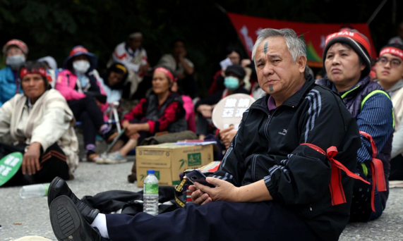
2) “Asia Cement: Following Rules or Pit Mining Human Rights” is about how in Taiwan a large cement company’s permit to mine on indigenous land was fast-tracked despite government regulations banning such a phenomenon. This led to public protests and opening debate over how the central government allows big business to override civil rights. Members of various Taiwan indigenous peoples were protesting the failure of the government to prioritize legal changes that would force companies like Asia Cement Corporation to take long-term responsibility for the land they mine. … This is about indigenous land rights, big business politics, human well-being, and about some of the nuanced challenges of transformative justice.

Published by The News Lens International: https://international.thenewslens.com/article/84693

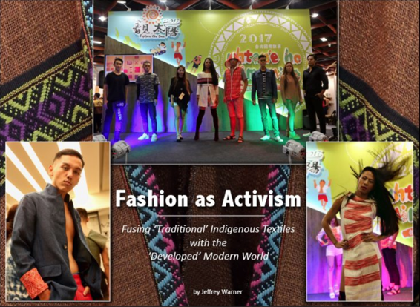
3) “Fashion as Soft Power Activism: Fusing Indigenous Textiles with the Modern World” explores the way that some indigenous people in Taiwan — by weaving the techniques, colors and patterns of their ancestors with modern-style ‘catwalk’ fashion design — are re-invigorating and restoring their millennia-old cultural heritages. Integrated into this story is dialogue regarding the semantics linked with Taiwan’s “Formosa” island history and the rooted societal impacts that government policies have had on this island’s indigenous peoples. This partnership between the indigenous elders and the youth is challenging some assumptions about indigenous peoples and what could be considered ‘traditional’ ways of life.

The full version (with photo gallery) is available here. … The News Lens International published another (similar) version.
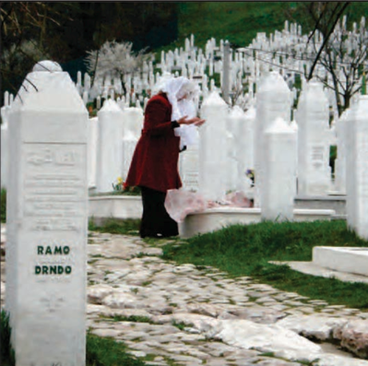
4) “Sarajevo Rose: A Tribute to Post Bosnian War Survival” offers insight into a post Bosnian War society. This is about how just because the bullets stop flying doesn’t mean the war is over. While doing relief and journalism work in Sarajevo, Bosnia, I meandered the bullet-riddled streets of Sarajevo, while observing the overall environment and local human behavior. I was enthralled (and deeply impacted) particularly by the long-term societal effects of the 1990s Bosnian War that ravaged this area and its peoples. I listened to the voices of a society forced to survive with less than the bare essentials for survival; this is while they fought a war where its origin and justification remain unclear to many of them. … This is about the human spirit’s profound ability to survive, for life to prosper, for people to heal and to forgive one another, and for a society to literally rise from the ashes – rebuild, against all odds, what could not be taken, what was possibly never really lost.

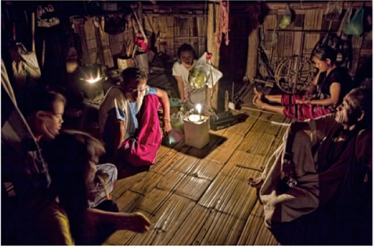
5) “Back to the Basics: Can’t Buy This Way of Life” takes you somewhere rarely seen by the public eye, into a quaint Pakagayor (a.k.a. ‘Karen’) village located in northern Thailand. While the ethnic indigenous people living here have long-since been tugged down from their highland forest homes and settled amid this lowland urban area, they are attempting to maintain fairly traditional lives. This is rapidly changing, however, with the further encroachment of the modern world. Their traditional culture is literally vanishing as capitalism-driven ‘development’ and technology-centered ‘modernity’ is perforating their socio-fabric and shifting centuries of learning and indigenous knowledge aside. A form of ethnocide is ensuing.

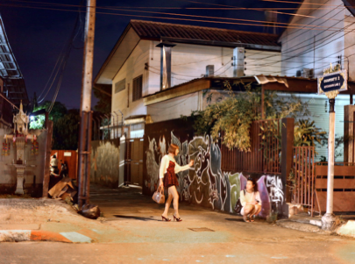
6) “Dinner with a ‘Sex Worker:’ The (True) Value of Money and People” is the tale of my encounter with a troubled but weary and gentle “sex worker” in northern Thailand. Using more money than she attempted to solicit me for sex, we experienced a humane and calorie-enriched exchange that to me depicts the power of choice, value of people and life, and the limitless depth of the human spirit. … This is a memoir of sorts, about (misunderstood) people, and how I believe that we should all be kind to each other and share our resources. This piece also attempts to disintegrate prominent misunderstandings about this minuscule segment of Thai culture. … We are often too quick to judge others.

Book Creations

7) The ‘De’ of Development: Ecosystems Services, Societal System State Shifts, and Our Transmuting
Human Condition in Context with Northern Thailand’s Top-Down Highlands Development

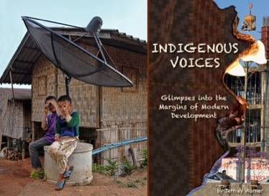
8) Indigenous Voices: Glimpses into the Margins of Modern Development

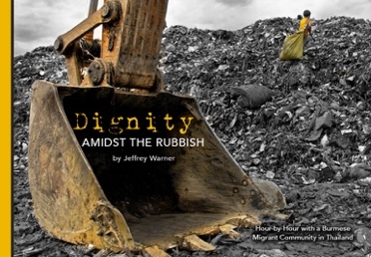
9) Dignity Amidst the Rubbish: Hour-by-Hour with a Burmese Migrant
Community in Thailand

10) Additional portfolio materials, travel articles, marketing advertorials, features, and documentary videos are available.

